show vlan brief on office switch
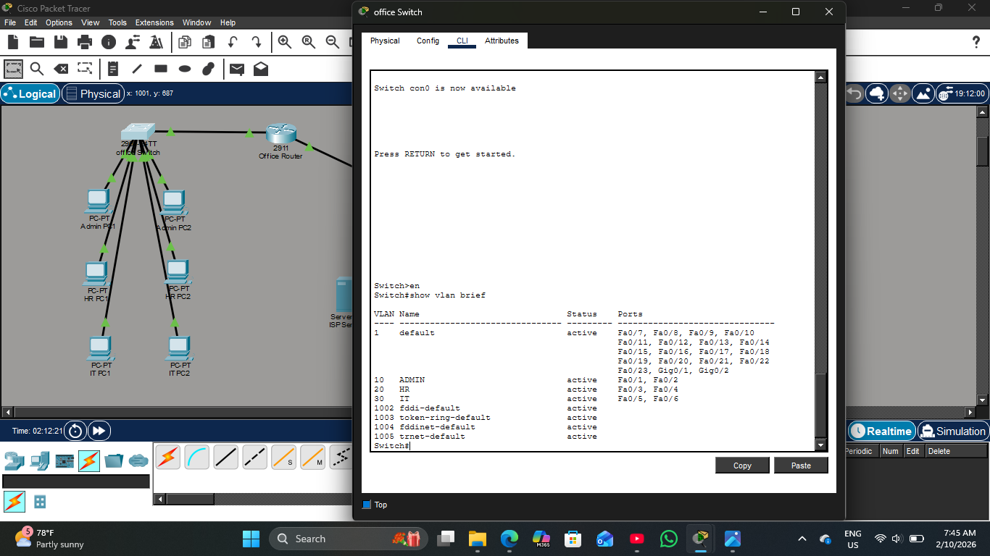

show ip route on office router
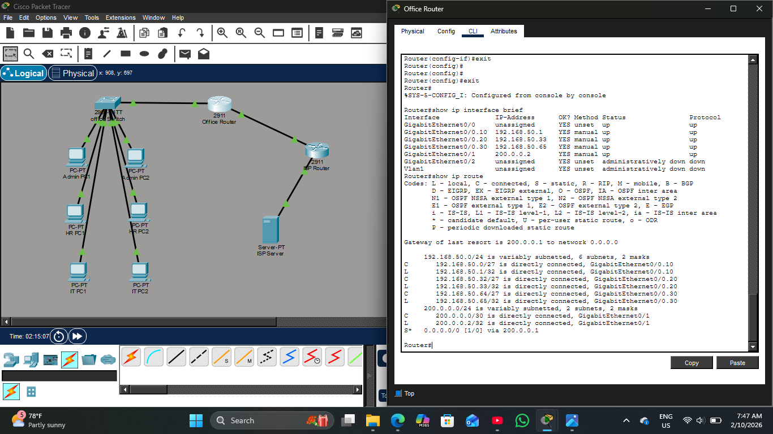

Show ip dhcp binding
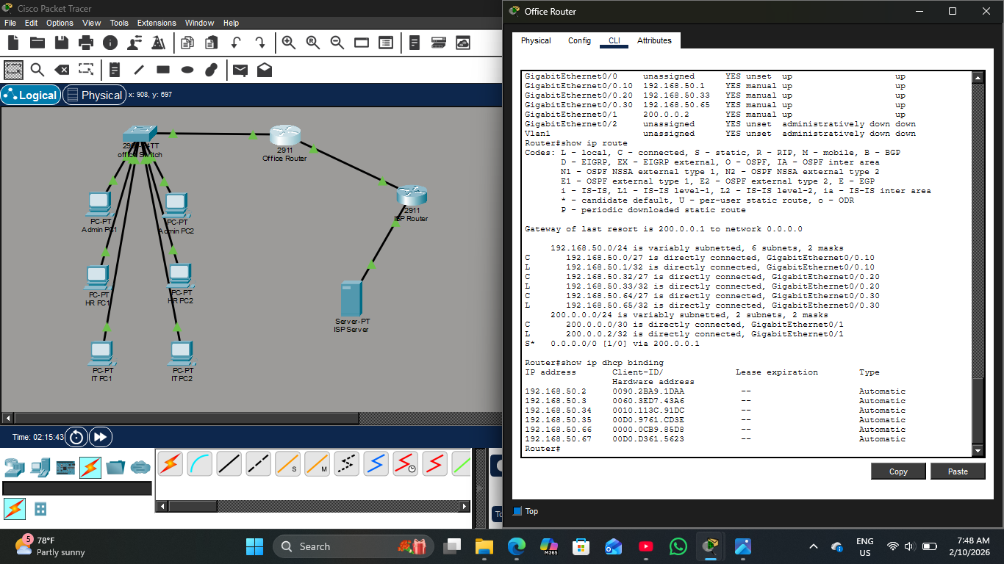

show ip nat translations
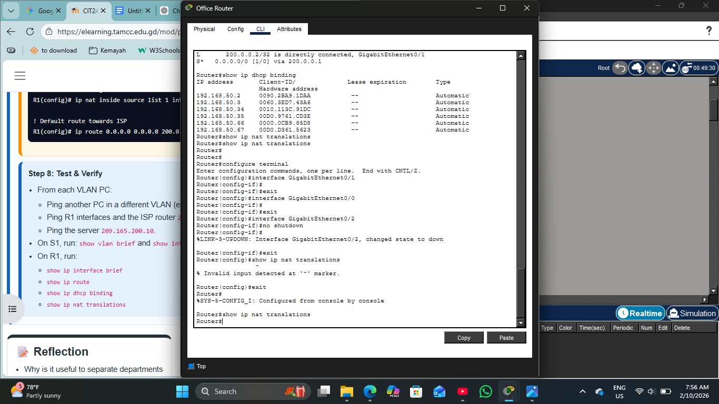

show ip nat translations was unsuccessful

Short note
I built a multi-department network using VLANs for segmentation and Router-on-a-Stick to enable inter-VLAN communication. I automated host addressing by configuring DHCP pools and implemented NAT Overload (PAT) to provide shared internet access through a single public IP. This can be verified by pinging the server.

